Hortex Foundation & FAO-FSP Stall at National Agriculture Technology Fair 2015

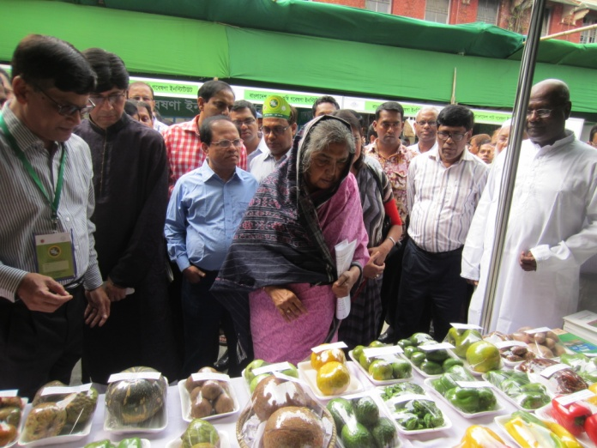
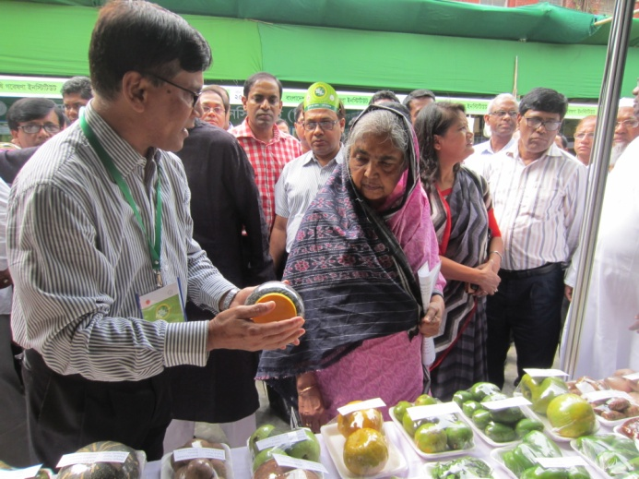
Hortex Foundation in collaboration with FAO-Food Safety Programme (FSP) participated in three days long National Agriculture Technology Fair 2015 being organized by Agriculture Information Service (AIS), Ministry of Agriculture, Govt. of Bangladesh during 05-07 April, 2015 at AKM Giasuddin Milky Auditorium premises, Farmgate, Dhaka where modern agricultural technologies like agro seed & machinery, bio-tech, research activities, information & communication technology, agricultural extension, postharvest & marketing technologies were demonstrated by 60 government, semi-government and private sector organizations. Matia Chowdhury MP, Hon’ble Minister, Ministry of Agriculture, Government of Bangladesh inaugurated the Fair as the Chief Guest while Md. Mokbul Hossain, Chairman, Parliamentary Standing Committee on Ministry of Agriculture was present as the Special Guest. Mr. Bijoy Bhattacharjee, Additional Secretary (Admn. & Input), Ministry of Agriculture, Govt. of Bangladesh presided over the inaugural session. Before the inaugural programme, the Minister and other delegates has paid a visit to the Hortex Foundation stall. Hortex Foundation displayed a good number of exportable fresh fruits and vegetables, canned pineapple, aloevera, baby corn, honey, flowers, export quality cartons incl. safe food related banner, festoons in the stall supported by FAO-FSP. Hortex stall is unique for displaying important technologies combining fruits, vegetables, processed agro-commodities and flowers of various colours that created immense interest of the visitors. From the Hortex stall, different technical bulletins, booklets, leaflets distributing and export info incl. safe food issues are also disseminating to the visitors. It believes that participation in the fair creates a huge impact on the image, uniqueness and endeavors of Hortex Foundation and FAO-FSP for the development and promotion of agricultural technologies, agribusiness, high value high quality agro-commodity export and food safety. Interested stakeholders are invited to visit the Hortex and FAO-FSP stall in the fair.
